Reference guide
Workflow Templates
This document provides information on the Workflow Templates window.

Contents
1. Introduction 3
2. Workflow Templates field descriptions 4
2.1 Details tab 4
2.1.1 Template Selection Criteria section 5
2.1.2 Tasks tab 6
2.1.3 Milestones tab 6
2.1.4 Triggers tab 6
2.1.5 Screen Layout tab 6
2.1.6 Custom Fields tab 7
3. Appendix 8
3.1 Workflow Process Types 8
3.2 Condition 1 options available per Process Type 15
3.3 Condition 2 options available per Process Type 20

Date | Version | Description of Change

- Introduction
Tasks, Milestones, and Triggers can be set up manually at the record level wherever Workflow is used in the system. Workflow templates are used to standardize Workflow & Tracking. This makes for fast, error-free processing built around your business needs. Workflow templates can be set up with Tasks, Milestones, and Triggers to show standard operating procedures based on your company needs or even your customer’s needs. The templates are then added to a job or record based on the criteria used in the template. These are usually set up by administrators or managers that have a good understanding of process flow and milestone tracking requirements.
CargoWise has several pre-defined Workflow Templates for Milestones and or screen layouts. It’s recommended that you review the system templates before creating any new templates.
In a Workflow Template record, the Workflow Template tabs and functionalities available for configuration varies depending on the Process Type selected.
Depending on the Process Type, Transport Mode and Direction selected, the system will use the Template Criteria to choose a best match. Refer to How-To Determine and Troubleshoot which Workflow Template will be applied.
Jobs can inherit Tasks, Milestones and Triggers from multiple matching Workflow Templates. The conditions where less specific templates can be applied is configured separately for Tasks, Milestones and Triggers. The benefit of this is to reduce the number of workflow templates required to be created. In the Edit Workflow Template window, Tasks, Milestones and Triggers can each have a fallback method specified. This controls the conditions where less specific workflow templates, which also match the same job, will also be applied. The fallback is configured individually so each type of template item can have different inheritance behavior.
For more information, refer to Update Note Workflow Template inheritance of Tasks, Milestones and Triggers.
For more information, refer to the following learning material:
Workflow Manager – Administration
Workflow Manager – How-to documents.

- Workflow Templates field descriptions
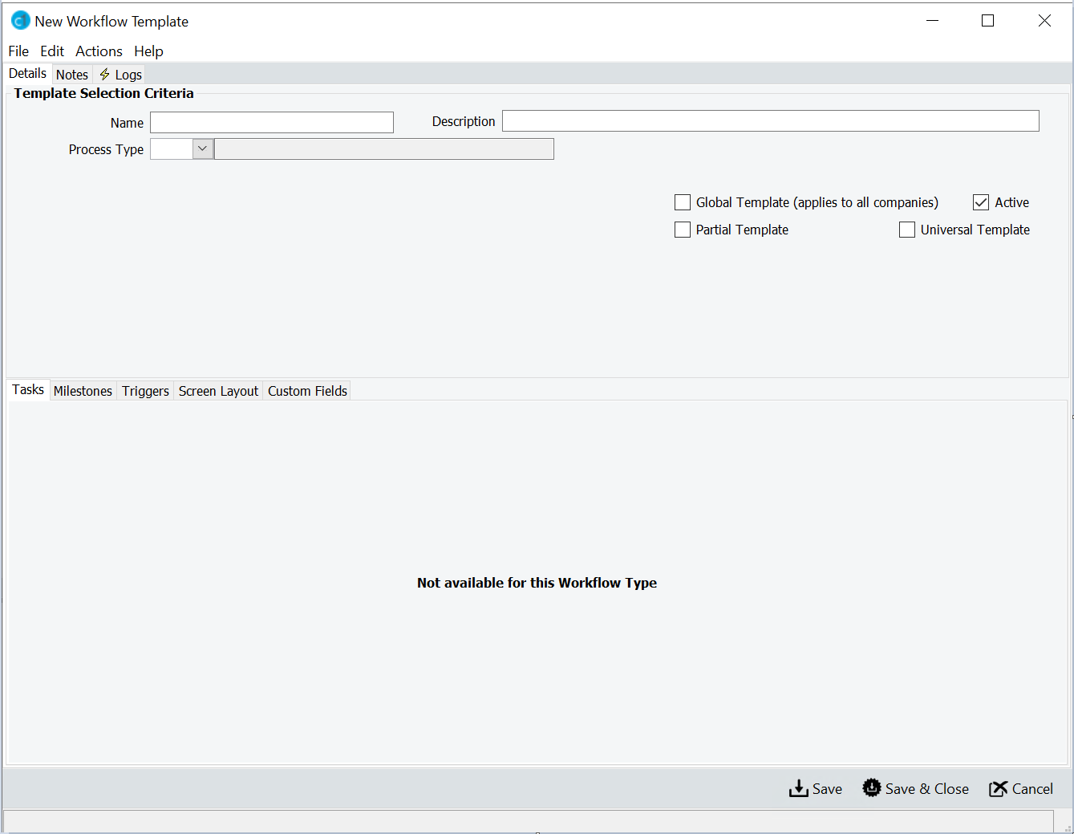
- Details tab
Fields and tabs will become visible when you choose the required Process Type. The Details tab is broken into the following sections and tabs:
- Template Selection Criteria
- Tasks
- Milestones
- Triggers
- Screen Layout
- Custom Fields

- Template Selection Criteria section
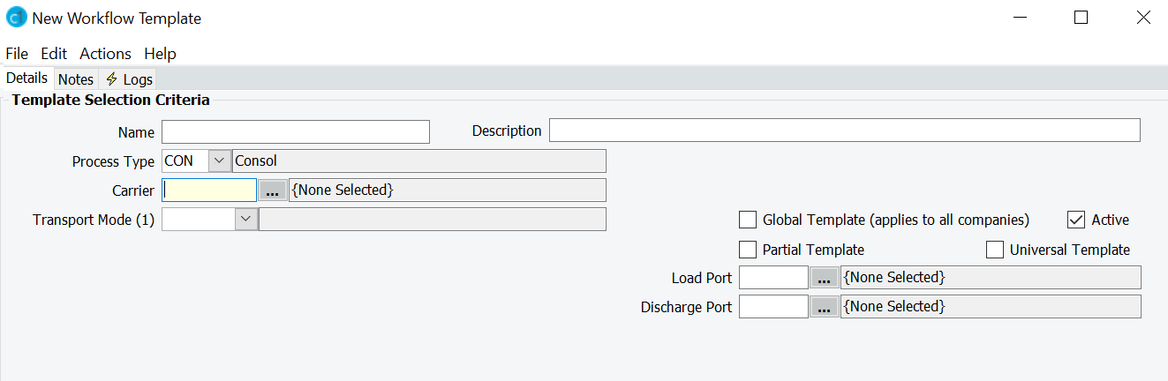
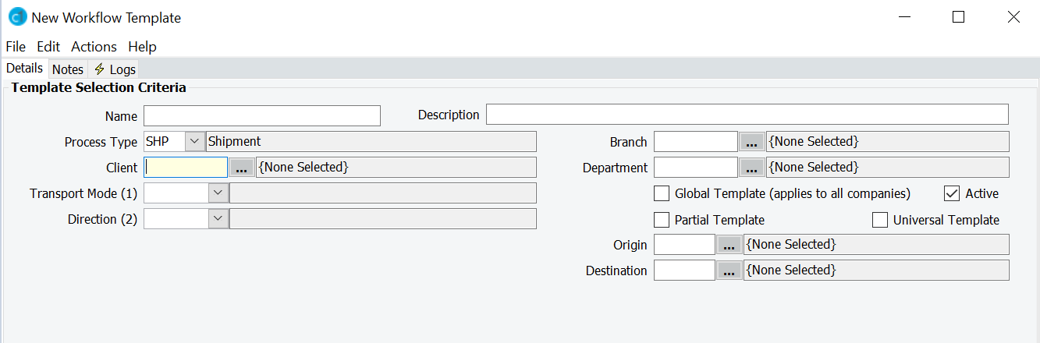

Name
Enter a unique name for the template. The Template Name (Source Template) can be included when you customize the columns under the Workflow & Tracking tab grid to determine which template was used on tasks, milestones, and triggers.

Description
Enter a meaningful description for the Workflow Template.

Process Type
Choose the job/record type from the drop-down menu. Use the Appendix: 3.1 Workflow Process Types in this guide.

Active
Untick the Active box if you do not want the template to be applied to any new jobs/records.

Partial Template
Tick the Partial Template box to set up a partial template. Refer to 1PRO047.

Universal Template
Tick the Universal Template box to set up universal trigger templates. Refer to 1PRO044.
- Tasks tab
Tasks are units of work that allow you to manually monitor daily activities. These have a start and completed time. Refer to 1PRO004.

Fallback Method
Fallback Method option | Description
AFB – Always falls back | Less specific templates are always considered along with this template.
EFB – Falls back if empty | Considers less specific template when no items from the template are defined. This is the default value.  Note: if you set conditions on a template, and none of the conditions are met, the system will continue to fall back to less specific templates. Should those conditions occur then the better matched template will apply, so the job/record will have multiple templates applied (previously applied templates will not be automatically removed once a condition from a better suited template is met).
NFB – Never falls back | Less specific templates are not considered along with this template. This option can be used to ensure that only the configured items will be applied to jobs/records. It can prevent falling back to a less specific template rather than applying no items, when the most specific template has no items configured.
- Milestones tab
Milestones are events driven for tracking and tracing of critical completion points. A milestone informs you and your clients on the status of a job. Refer to 1PRO005.
- Triggers tab
Triggers perform an action in response to an event occurrence or field change. Refer to 1PRO007.
- Screen Layout tab
Changing the layout of specified fields/sections is available for certain Process Types. Refer to 1PRO014.

- Custom Fields tab
Custom Fields allow you to add your own customized fields to certain Process Types. Refer to 1PRO015

- Appendix
- Workflow Process Types
Code | Description | Module
ACA | Accreditation Attempt | Maintain > Human Resources > Learning & Development > Accreditation Attempts.
ACI | ACI & eManifest (CA only) | Operate > Customs > Global Customs > CA eManifest Forwarder.  Refer to Update Note: Workflow & Tracking for ACI & eManifest Forwarder.
ACR | Air Cargo | Operate > Customs > Air Cargo Report.
AMS | Automated Manifest System (US only) | Operate > Customs > Customs Global > US AMS.
AMW | ACCESS Manifest (SG only) | Operate > Customs > Customs Global > Global Manifest.
AOG | Outturn & Gate In/Out (ZA only) | Operate > Customs > Customs > Outturn & Gate In/Out.
BKN | Shipping Manager Booking | Operate > Liner & Agency > Bookings.
BOL | Bill of Lading | Operate > Liner & Agency > Bills of Lading.
BRK | Declaration Job | Operate > Customs > Customs Declaration.
CAE | CA eManifest Forwarder | Operate > Customs > Global Customs > CA eManifest Forwarder.  Refer to Update Note: Workflow & Tracking for ACI & eManifest Forwarder.
CAM | Campaign | Manage > Sales & Marketing > Campaign Management.
CBW | Collection Batch | Manage > Receivables > Collection Batch.
CIV | Commercial Invoice | Operate > Customs > Commercial Invoice.
CLL | CFS Load List | Operate > Forwarding > CFS/CTO > Load Lists.
CMM | Container Movement | Operate > Liner & Agency > Container Movements.
CNS | Shipper Job Container/Break-bulk | Operate > Liner & Agency > Bills of Lading.
CNT | Container | Operate > Forwarding > Forwarding > Containers.
COM | Communication Manager | Manage > Sales & Marketing > Campaign Management.
CON | Consol | Operate > Forwarding > Forwarding > Consolidations.
COW | Collection Order | Manage > Receivables > Collection Orders.
CSH | CFS Shipment / Gate Pass | Operate > Forwarding > CFS/CTO > Shipments / Gate Pass.
CSM | Container Stock Manager | Operate > Liner & Agency > Container Manager.
CSQ | Compliance Sequence | Manage > Payables/Receivables > AP/AR Invoice > Compliance Sub Type.
CST | Customer Service Ticket | Operate > Productivity Tools > Customer Service Tickets.
DRW | Drawback Declaration Job | Operate > Customs > Customs Declarations / Shipment > Type DRW – Drawback.
GLB | Company Tariff | Manage > Tariffs & Rates > Company Tariff.
GMB | Global Manifest Bills | Operate > Customs > Customs Global > Global Manifest Bill.
GRP | Group | Maintain > User Admin > Group
HAC | House Air Cargo | - Operate > Customs > Customs > Air Cargo House.  - Operate > Customs > CCS-UK > House Bills (UK login companies only).
HHB | HVLV Booking Header | Operate > Transport Booking > Bookings > Build HVLV Transport booking > Header.
HLB | HVLV Booking Lines | Operate > Transport Booking > Bookings > Build HVLV Transport booking > Lines.
HRA | Job Application | Maintain > Human Resources > Recruiter > Job Application.
HRC | Human Resources Campaign | Maintain > Human Resources > People Operations > HR Campaign Management.
HVC | HVLV Consignment | Operate > Forwarding > Forwarding > HVLV Booking Headers.
HVH | HVLV Shipper Header | Operate > Transport > Transport Booking > Build HVLV Transport Booking > Shipper Header.
INB | US InBond (US only) | Operate > Customs > Customs Declaration > In-Bond tab.
INQ | Sales Inquiry | Manage > Sales & Marketing > Inquiry Manager.
ISF | Importer Security Filing | Operate > Customs > Customs Global > US Importer Security Filing.
JPA | JP AFR | Operate > Customs > Customs Global > JPAFR.
LTC | Land Transport Consignment | Operate > Transport > Land Transport > Booking Consignments.
LTL | Port Transport Leg | Operate > Transport > Port Transport > Leg Planner.
MAN | e-Manifest | - Operate > Customs > Customs Global > e-Manifest.  - Operate > Customs > Customs Global > CA eManifest Forwarder.
NCT | NCTS | Operate > Forwarding > Shipment > Entry Details > MRN (NCTS).
OPP | Sales Opportunity | Manage > Sales & Marketing > Opportunity Management.
OPR | Organization Product Relationship | Maintain > Warehouse > Product.
ORD | Forwarding Order | Operate > Forwarding > Order Manager > Orders.
ORG | Organization | - Maintain > Master Data > Organizations.  - Manage > Sales & Marketing > Client Intelligence.
PER | Person Intelligence | Maintain > Master Data > Person Intelligence.
PKG | Package | Maintain > Reference Files > Package Types.
PNV | AP Invoice | Manage > Payables > Payables Transactions > AP Invoice.
POD | Payable Order | Manage > Payables > Purchase Orders.
PPA | AP Payment Approvals | Manage > Payables > Payment Processing.
PPT | AP Payments | Manage > Payables > Payables Transactions / Enquires.
PRC | AP Receipts | Manage > Payables > Payables Transactions / Enquires.
PRD | Product | Maintain > Customs > Customs Files > Products.
PRO | Protest Declaration Job | Operate > Customs > Customs > Protest.
PTW | Process Task | Maintain > System > Service Tasks.
QBK | Quoted Booking | Operate > Forwarding > Bookings > Booking with Quote.  Note: when selecting QBK, the Type field should be completed, to specify if the Template is to apply to BWQ - Booking with Quote, QBN - Quick Booking, or SQT - One Off Quote.
QTN | Quotation | Manage > Tariffs & Rates > Quotations.
REC | Reconciliation Declaration Job | Operate > Customs > Reconciliation.
RNV | AR Invoice | Manage > Receivables > Receivables Transactions > AR Invoice.
RPA | AR Payment Approvals | Manage > Receivables > Payment Processing.
RPT | AR Payments | Manage > Receivables > Receivables Transactions / Enquires.
RRC | AR Receipts | Manage > Receivables > Receivables Transactions / Enquires.
SAL | Client Rate | Manage > Tariffs & Rates > Client Rates.
SAR | Staff and Resources | Maintain > User Admin >  Staff and Resources.
SCH | Sailing Schedule | Operate > Schedules > Sailing Schedule.
SCO | Sea Cargo Outturn (AU only) | Operate > Forwarding >  CFS/CTO > Sea Cargo Outturn.
SCR | Sea Cargo (AU only) | Operate > Customs > Customs > Sea Cargo Report.
SCU | Sea Cargo House (AU only) | - Operate > Customs > Customs > Sea Cargo Report > New / Edit Consol window > Details tab > Custom Fields tab.  - Operate > Customs > Customs > Sea Cargo Report > New / Edit Sea Cargo window > Details tab > House Bills tab > Custom Fields tab.  - Operate > Forwarding > Forwarding > Consolidations> New / Edit Sea Cargo window > Sea Cargo tab > House Bills tab > Custom Fields tab.
SHP | Shipment | Operate > Forwarding > Shipments.
SIM | Simulation Job | Maintain > Archive Manager > Archive Schedule.
SPA | Shipment Pre Advice | Operate > Forwarding > Order Manager > Shipment Pre Advice.
STM | Statement (US only) | Operate > Customs > Statements / ACH Payments.
TBC | Transport Booking Confirmation | Operate > Forwarding > Forwarding > Transport Booking.
TBI | Transport Booking Instruction | Operate > Transport > Transport Booking > Bookings.
TBM | Transport Booking | Operate > Transport > Transport Booking > Bookings.
TBW | Transport Booking Consolidation | Operate > Transport > Transport Booking > Consolidated Bookings.
TCW | Transport Consignment | Operate > Transport > Land Transport > Booking Consignments.
TRI | Consignment Run Sheet Instruction | Operate > Transport > Land Transport > Run Sheets.
TRN | Port Transport | Operate > Transport > Port Transport > Transport Jobs.
TRS | Transport Run Sheet | Operate > Transport > Port Transport > Run Sheets.
UBR | Air Cargo Outturn | Operate > Forwarding > CFS/CTO > Air Cargo Outturn Bills.
WAJ | Warehouse Adjustment | Operate > Warehouse > Adjustments.
WIN | Warehouse Receive | Operate > Warehouse > Receive.
WKI | Work Item | Operate > Productivity Tools > Work Items.
WKP | Project | Operate > Productivity Tools > Projects.
WOU | Warehouse Order / Release | - Operate > Warehouse > Orders.  - Operate > Warehouse > Release.
WPU | Warehouse Pick | Operate > Warehouse > Picking.
WSC | Warehouse Stocktake | Operate > Warehouse > Stocktake/Cycle Count.
WTF | Warehouse Transfer | Operate > Warehouse > Transfers.
WVO | Warehouse VAS Order | Operate > Warehouse > VAS Orders.

- Condition 1 options available per Process Type
Condition 1 | Process Type
 | SHP - Shipment | CON - Consol | TBM – Transport Booking | BRK – Declaration Job
IMP – Import | Basic Registration tab > Details section > Origin and Destination fields in relation to your login company. | Details tab > Consol Details section > 1st Load and Last Discharge fields in relation to your login company. |  | Declaration tab > Shipment Type section > Shpt Type field.
EXP - Export | Basic Registration tab > Details section > Origin and Destination fields in relation to your login company. | Details tab > Consol Details section > 1st Load and Last Discharge fields in relation to your login company. |  | Declaration tab > Shipment Type section > Shpt Type field.
DOM - Domestic | Basic Registration tab > Details section > Origin and Destination fields in relation to your login company.
ORL – Origin different from First Load Port | Basic Registration tab > Details section > Origin field different to First Load Port field on attached consolidation.
DSD – Destination different from Final Discharge Port | Basic Registration tab > Details section > Destination field different to Final Discharge Port field on attached consolidation.
CDL – Link to the Consol Discharge Transport Leg | Routing tab > Leg Details section > Is Linked box.
CPL – Link to the Consol Pre-Carriage Transport Leg | Routing tab > Leg Details section > Is Linked box.
PUC – When the current company handles the Pickup Cartage | Pickup tab > Pickup Transport Company field entered with an organization proxy.
DLC – When the current company handles the Delivery Cartage | Delivery tab > Delivery Transport Company field entered with an organization proxy.
BRK – Has an attached Brokerage job | The declaration has been created by clicking on the Brokerage tab or setting up the Importer / Exporter with a preferred Broker that is your organization proxy.
ACA – Has an attached Air Cargo Job | The Air Cargo tab has been accessed.
2LG – Has a 2nd Intermediate Transport Leg |  | Yes
3LG - Has a 3rd Intermediate Transport Leg |  | Yes
4LG - Has a 4th Intermediate Transport Leg |  | Yes
NEX – Import, Ex-warehouse, Other |  |  |  | Declaration tab > Shipment Type section > Shpt Type field.

- Condition 2 options available per Process Type
Condition 2 | Process Type
 | SHP - Shipment | CON - Consol | TBM – Transport Booking | BRK – Declaration Job
IMP - Import | Basic Registration tab > Details section > Origin and Destination fields in relation to your login company. | Details tab > Consol Details section > 1st Load and Last Discharge fields in relation to your login company. |  | Declaration tab > Shipment Details section > Port Of Origin and Final Destination fields.
EXP - Export | Basic Registration tab > Details section > Origin and Destination fields in relation to your login company. | Details tab > Consol Details section > 1st Load and Last Discharge fields in relation to your login company. |  | Declaration tab > Shipment Details section > Port Of Origin and Final Destination fields.
DOM - Domestic | Basic Registration tab > Details section > Origin and Destination fields are within the same country.
LCL – Less Container Load | Basic Registration tab > Mode section > Container field. | Details tab > Consol Details section > Container Mode field. |  | Declaration tab > Shipment Type > Container field.
FCL – Full Container Load | Basic Registration tab > Mode section > Container field. | Details tab > Consol Details section > Container Mode field. |  | Declaration tab > Shipment Type > Container field.
GRP – Groupage/Freight All Kinds | Yes | Details tab > Consol Details section > Container Mode field.
LSE – Loose | Basic Registration tab > Mode section > Container field. | Details tab > Consol Details section > Container Mode field.
ULD – Unit Load Device | Basic Registration tab > Mode section > Container field. | Details tab > Consol Details section > Container Mode field.
BBK – Break Bulk | Basic Registration tab > Mode section > Container field. | Details tab > Consol Details section > Container Mode field. |  | Declaration tab > Shipment Type > Container field.
BLK – Bulk | Basic Registration tab > Mode section > Container field. | Details tab > Consol Details section > Container Mode field. |  | Declaration tab > Shipment Type > Container field.
LQD- Liquid | Basic Registration tab > Mode section > Container field. | Details tab > Consol Details section > Container Mode field. |  | Declaration tab > Shipment Type > Container field.
ROR – Roll On/Roll Off | Basic Registration tab > Mode section > Container field. | Details tab > Consol Details section > Container Mode field.
CON – Agent Consolidation | Basic Registration tab > Mode section > Container field. | Yes
LTL – Less Truck Load | Basic Registration tab > Mode section > Container field. | Details tab > Consol Details section > Container Mode field.
FTL – Full Truck Load | Basic Registration tab > Mode section > Container field. | Details tab > Consol Details section > Container Mode field.
OBC – On Board Courier | Basic Registration tab > Mode section > Container field. | Yes
UNA - Unaccompanied | Basic Registration tab > Mode section > Container field. | Yes
BCN – Buyer’s Consol Master | Basic Registration tab > Mode section > Type field.
BCS – Buyer’s Consol Sub | Yes
CLD – Co-Load Master | Basic Registration tab > Mode section > Container field.
CLS – Co-Load Sub | Related Shipments tab.
ACM – Assembly Master | Basic Registration tab > Mode section > Container field.
ASS – Assembly Sub | Yes
REL – Release Type | Basic Registration tab > Details section > Release Type field. | Details tab > Shipments grid > Release Type column.
UDF – User Defined | Doc Data > User Defined Data tab. | Doc Data > User Defined Data tab. | Doc Data > User Defined Data tab. | Doc Data > User Defined Data tab.
BCN – Buyer’s Consolidation |  | Details tab > Consol Details section > Container Mode field.
NEX – Import, Ex-warehouse, Other |  |  |  | Declaration tab > Shipment Type section.

Support: Press the F1 key from anywhere within CargoWise to raise an eRequest.

